Edge Delivery Services: Document-Based Authoring Lab Session
  - Hands-On Experience with Lightning-Fast Publishing

Lab Session Structure
- Setup Edge Delivery project (Developers)
- Publish / Preview content – Sidekick (Content Authors & Developers)
- Utilizing Share point for authoring content.( Content Authors & Developers)
- Create new page and preview/publish (Content Authors & Developers)
- Create new block (Developers)

Prerequisite
- Github account (for Devs)
- Adobe Share point access (Users to be added)
- Understand basics of HTML, CSS & JavaScript
- Node/npm installed for local development (only for Devs)

Participant Takeaways
- First-hand experience with the entire content lifecycle—preview and publish—without leaving the document editor.
- Understanding how Edge Delivery Services and document-based authoring combine to drive digital experience innovation.
- How to apply different styles

Steps to setup Edge Delivery Services project|
- Create new repo using use this template option
Repo - https://github.com/adobe/aem-boilerplate
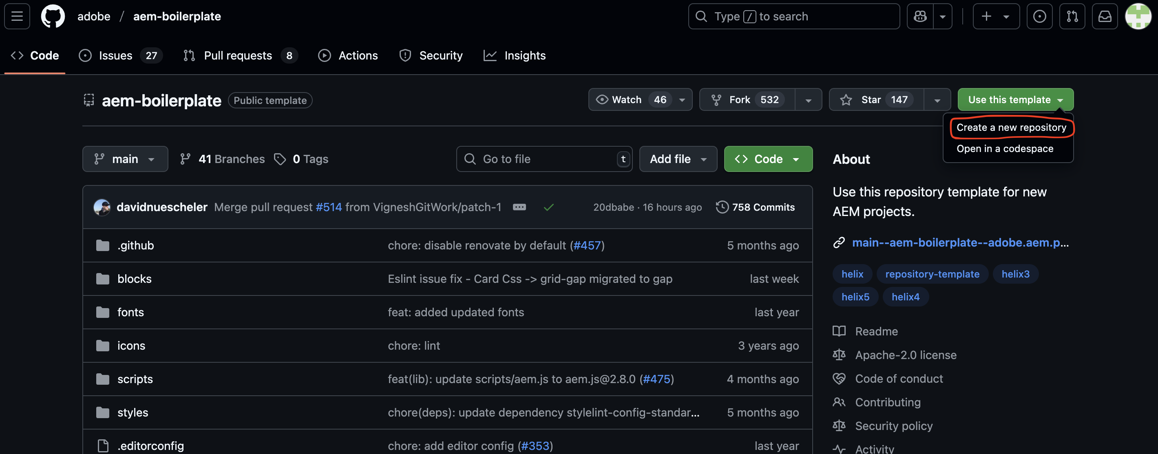

- Click the Use this template button and select Create a new repository, and select the user org that owns the repository
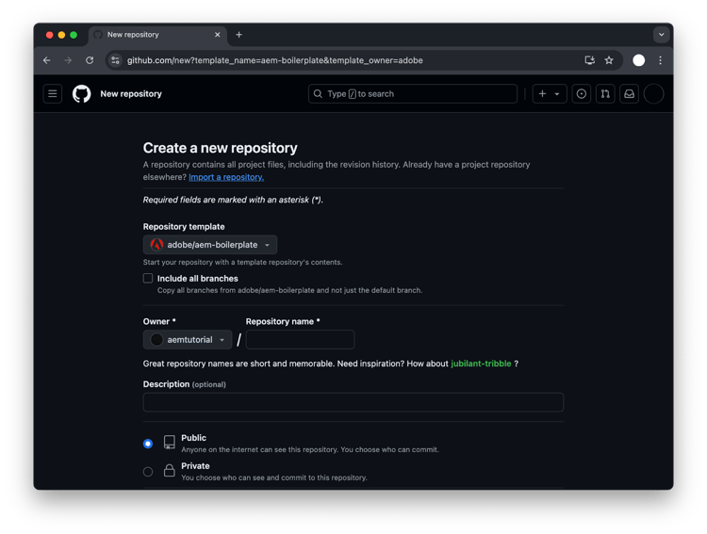
- Install the AEM Code Sync GitHub App on your repository by visiting this link: https://github.com/apps/aem-code-sync/installations/new
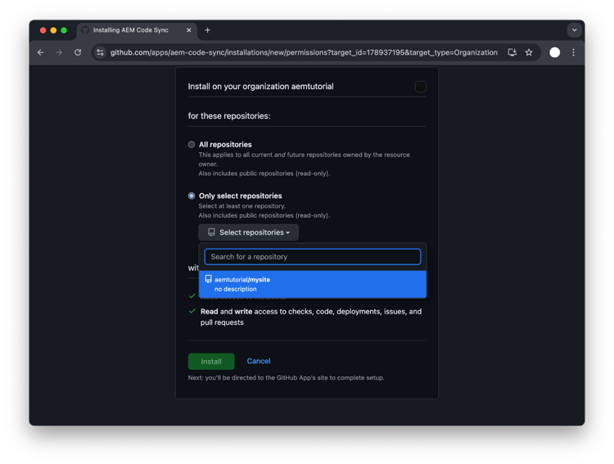

- Copy the started content to your Share point
- Share docs with helix@adobe.com
- Update share point path in fstab.yaml configuration file
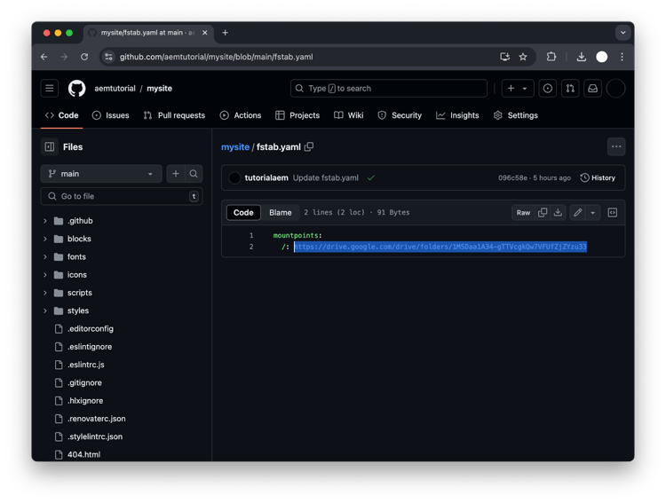

AEM Sidekick to preview or Publish

- Install the Sidekick Chrome extension using https://chromewebstore.google.com/detail/aem-sidekick/igkmdomcgoebiipaifhmpfjhbjccggml

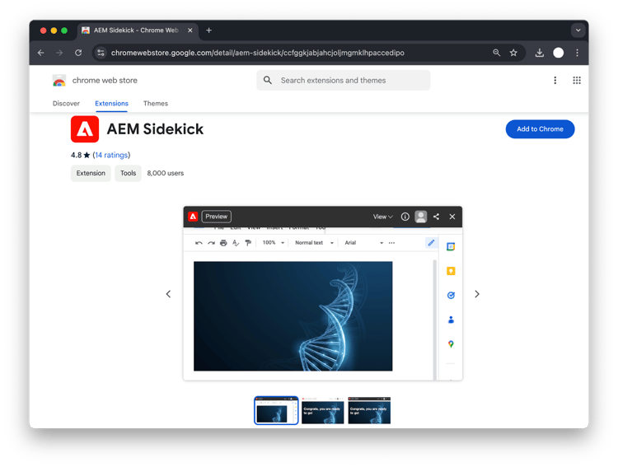

- Pin the extension to make it easier to find it.

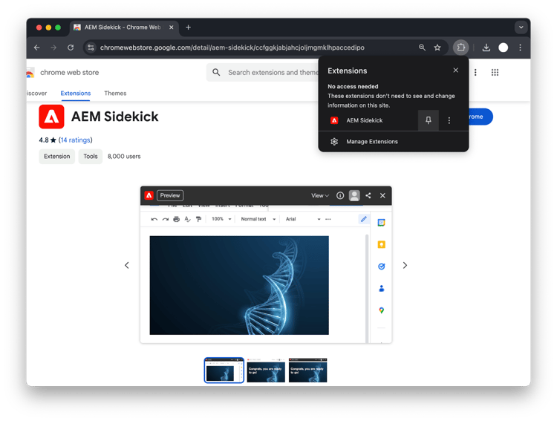

- To set up the Chrome extension, go to your previously shared Google Drive folder and click the extension icon in the browser toolbar and select Add this project
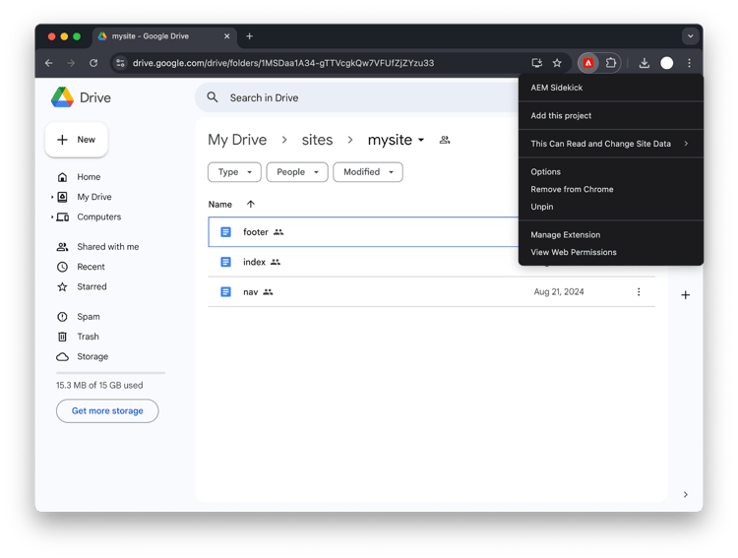
- you are now ready to preview and publish your content from your Google Drive.

- Open the index doc file and make some changes. Activate the Sidekick by clicking on your pinned extension and you can preview or publish the content.

For Content Authors :
Create new Page
- Go to your google drive and create a new file. Right click and click on Google Docs.
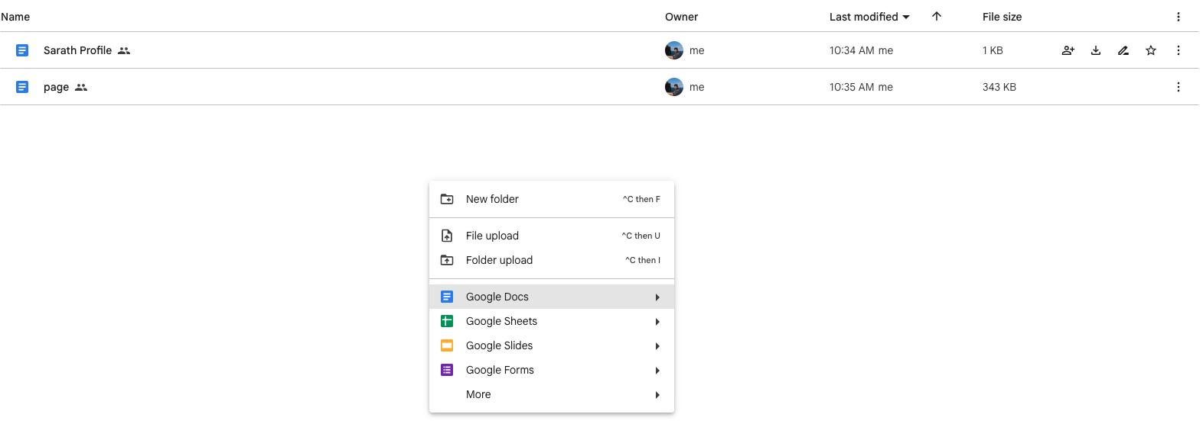
- Click on create and share

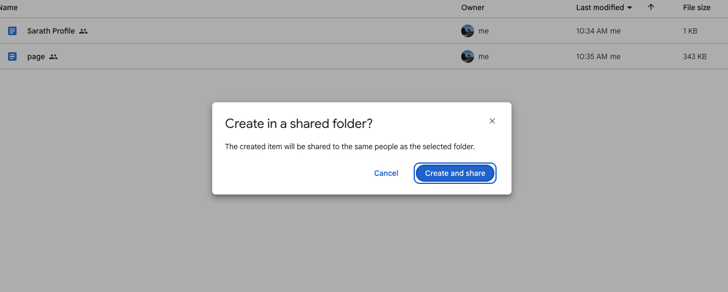
- Name the file to myProfile

- Create default content (write any free text).
- Apply Default content & styles to the content – styles (H1, H2..etc.,)
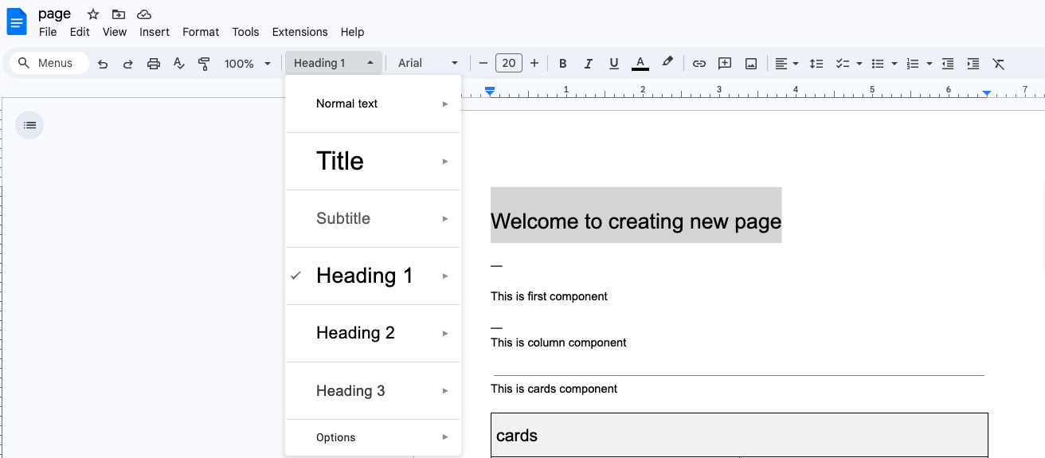

- To add a new section simply use 3 hyphens or horizontal line(click on insert option-> Horizontal line)


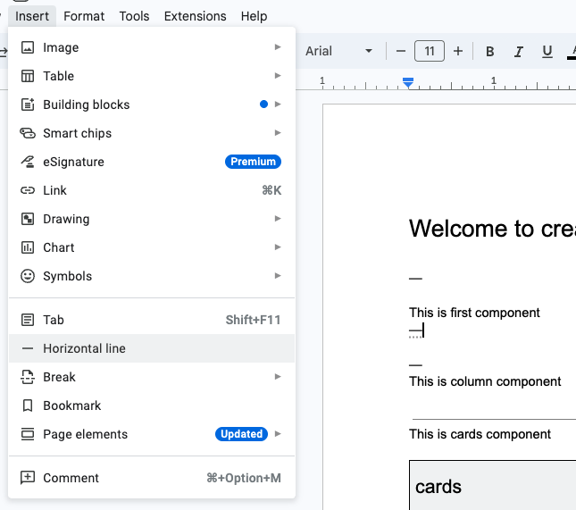

- Author the block component (cards)
Insert Table
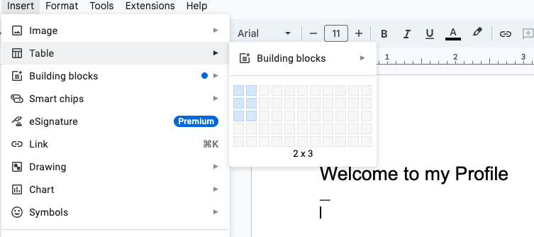
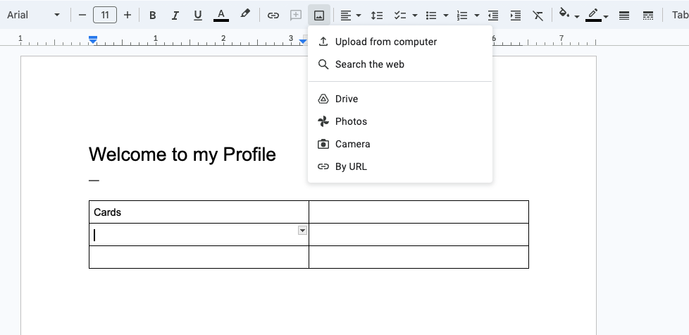
- Preview the content using sidekick
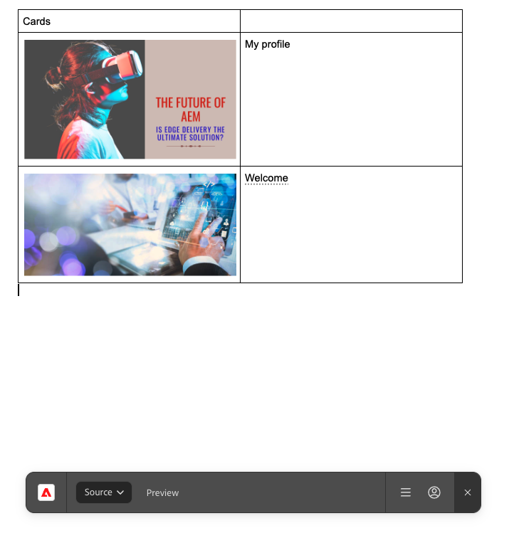
- Publish the content

For Developers : To get started with development.

- Install the aem-cli plugin and check out the code repository

npm install -g @adobe/aem-cli
git clone https://github.com/<owner>/<repo>

- From there change into your project folder and start your local development environment using the following.
cd <repo>
aemup

- This opens http://localhost:3000/ and you are ready to make changes.
- Test your changes locally and then follow the standard process to push the code.

Lab Exercise :

Create a new block (profile).

Sample code reference: https://github.com/sarathraju/skillUp/tree/main/blocks/profile

Amend changes in your project and add new styles

